Drone Configurator ReadME

This file explains the steps required to operate small UAV sizing Knowledge Based Engineering Application. Please see our documentation by firing the ‘open_documentation’ attribute in the root ‘mainUAV’ class.

1. Fill in the ‘userinput.xls’ file with the desired mission requirements. This file is in the root/user folder. (Filling in the input sheet is optional, as the design parameters can be edited in the ParaPy property grid and there are default values.)
2. Open the ‘main.py’ file in the root folder in PyCharm and run the script. Please wait for the ParaPy GUI to open. The CAD viewport will be empty and the product tree will be as shown in the left figure below. The right figure shows the property grid, containing inputs, attributes and Parts.

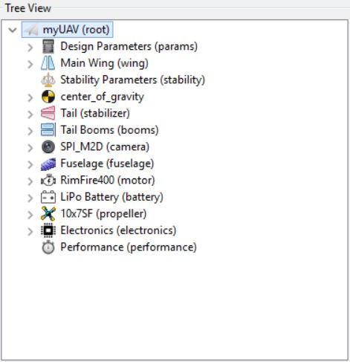 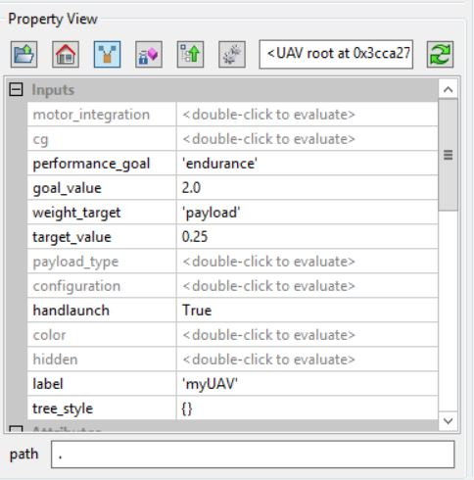

1. Navigate to the attribute named ‘get_userinput’ in the root level ‘myUAV’ class to load the mission requirements set in the previous step (This step is also optional. If this step is skipped, a UAV is created from the default values for all design variables.).
2. Double left click on the ‘myUAV’ root class to create the UAV.
3. Next, YOU MUST double left click on the attribute ‘final_cg’ in the root level ‘myUAV’ class. This will converge the tail sizing with the center of gravity. A plot of the center of gravity convergence will appear in the PyCharm IDE.
4. Next you may browse through all ‘Parts’ of the product tree to see the UAV design. These parts include the main wing design, the longitudinal stability parameters, center of gravity position in 3D, the horizontal and vertical tails, EOIR payload, fuselage and boom structure design, motor and propeller choice, battery sizing and electronics locations. If the hidden attribute is changed to false in the ‘Fuselage’ part, the internal components may be seen. The plots described below are saved to the root/user/plots folder after firing.
   1. In the ‘Main Wing’ part, two attriutes ‘plot_liftgradient’ and ‘plot_momentgradient’ plot C_la and C_ma when fired
   2. In the ‘Stability Parameters’ part, the Scissor Plot can be made by firing the ‘plot_scissordiagram’ attribute.
   3. In the ‘Propeller’ part, the propeller efficiency vs. airspeed is plotted by firing the ‘efficiency_plotter’ attribute.
5. The performance of the UAV is evaluated in the ‘Performance’ part. Here, if the ‘plot_airspeed_vs_power’ attribute is fired, all power components are plotted against flight velocity. The CD0 used in these calculations is calculated using the final wetted areas extracted from ParaPy. The maximum range and endurance speeds are extracted and the final mission requirements are recalculated and shown in the plot’s legend. The lift to drag ratio is plotted in the ‘plot_lift_to_drag’ attribute.
6. The relevant UAV design parameters may be exported to the ‘output.xls’ file in the root/user/results folder by firing the ‘write_excel’ attribute in the root ‘mainUAV’ Class.
7. The ‘.stp’ file can be exported by firing the ‘write_step’ attribute in the root ‘mainUAV’ Class. This file is in the root/user/model folder.
8. If desired, one may change design variables, BUT YOU MUST invalidate the attribute from step 5 and then re-fire it. This is due to the lazy evaluation of ParaPy and the new CG must converge again with the horizontal tail size. Only after this, are the performance results consistent.
9. Enjoy!